
July 2015 Volume IX, No. 3
Among Friends

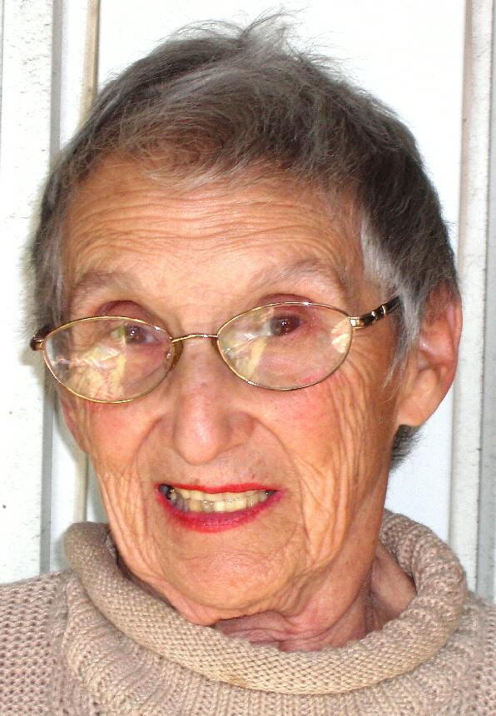 | “  PRESIDENT’S MESSAGE  by Marion Damick  I'm writing this in May when it's supposed to be spring – but it feels like summer.  Everything is blooming at once in my garden – including | When on a summer’s morn I wake  And open my two eyes,  Out to the clear, born-singing rills  My bird-like spirit flies.  To hear the Blackbird, Cuckoo, Thrush,  Or any bird in song;  And common leaves that hum all day  Without a throat or tongue.  And when Time strikes the hour for sleep,  Back in my room alone,  My heart has many a sweet bird’s song —  And one that’s all my own.  W. H. Davies 1871-1940  Summertime: Finally – this is what we looked forward to last winter while cleaning the ice off of our cars, sliding on slippery roads, and doing our best not to hit another car driving home from work in the dark. The only thing that kept us going was the thought that someday soon it would be sunny, warm, and beautiful.  Now we return home while it is still light, giving us a few hours of daylight and perhaps time to enjoy our gardens. So next time you find yourself complaining about the heat, remember, the winter will be here soon enough.  WELCOME, NEW MEMBERS  Lucretia Elson  Darlene Racis  Bette Rom  Join us at our regular  Friends Meetings:    July 11 at 10 AM  No meeting in August  Saturday Sept 12 at 10 AM  Saturday Oct 3 at 10 AM
  EDITOR’S CORNER  by Joan Schwartzman  When On a Summer’s Morn | 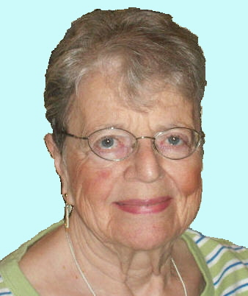
the weeds. It's good – and it's not good. Too much at one time...not spread out so it can be used and enjoyed throughout the next couple of months.

It seems we're in somewhat the same situation at the library. Several staff have left; our Amazon is temporarily down; the floor had to be repaired, so shelves were moved into the Friends of the Library workroom/office, causing much clutter; an important volunteer position has to be filled – so it goes, all concurrently. Plus – every day some rain must fall.

So – I should be encouraging everyone – right? Fuggedaboudit! It's life – or death (I went to 3 funerals this week).

But – I did have a most pleasant experience for which I'm thankful – the Hot Pants ladies quartet at our annual meeting last month. If you missed it – that’s too bad. Maybe you can catch them someplace in town. They were a lot of fun – plus you also missed the cookies. Remember to attend the FOL Annual Meeting next year... see you there in 2016.
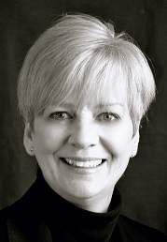 | Adult Summer Reading  by Jody Bell, Branch Manager  There’s plenty of summer left for adult summer reading. It’s not too late to set your Summer Reading goals!

Summer Reading registration officially began on Monday, June 8th, but there is still time to join in the fun. This summer we are asking our adult participants to create any reading goal that is meaningful to them. For example, customers can set goals to read a different genre, read to learn a new skill, or read a particular author. This approach gives everyone the chance to focus on what they are reading, instead of how much. If you haven’t already done so, I would encourage you to register at http://www.carnegielibrary.org/summer/ and begin logging your progress. Our expert team of librarians will offer encouragement and reading recommendations along the way. Plus, you could win some great prizes! Happy Reading & Happy Summer!
Published by the Friends of the Squirrel Hill Library, 5801 Forbes Avenue, Pittsburgh, PA 15217 412-422-9650
Editor: Joan Schwartzman Mailing list: Allison Marciszyn
Production: Lorraine S. Caplan, Dean Damick, Marion Damick, Allison Marciszyn, Margie Spenser, Serena Spenser
Websites: www.carnegielibrary.org/locations/squirrelhill www.pittsburghusedbooks/friends
E-mail: friends@pittsburghusedbooks.com membership email (Allison): SqHiFriendsLib@gmail.com
Friends online storefront: www.amazon.com/shops/sqhill used book email (Pat): SQhillfr@gmail.com
Online newsletter: www.pittsburghusedbooks.com/newsletters

July 2015 | Among Friends | Volume IX, No. 3

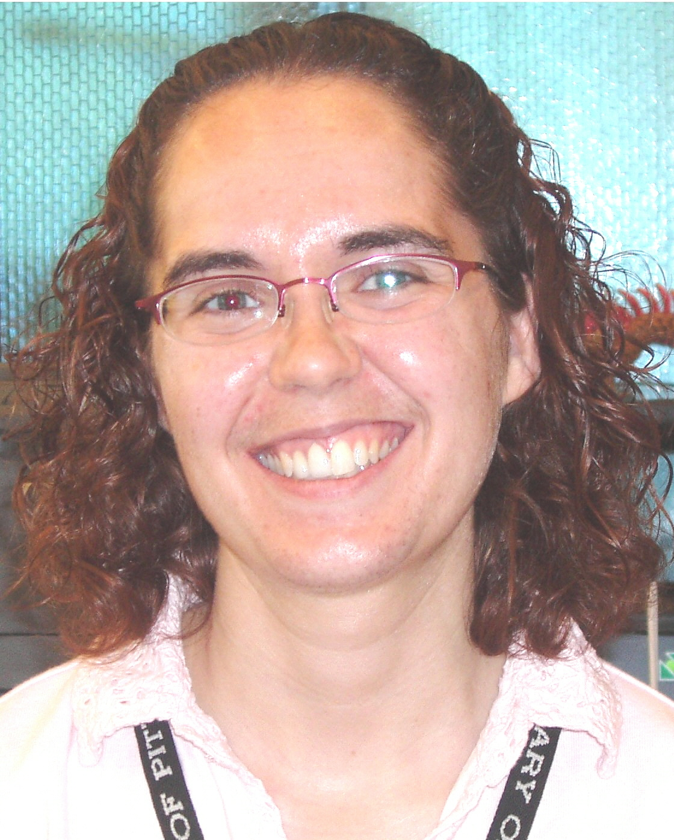 | Children’s Room Summer Happenings – 2015  by Megan Fogt, Manager of Children’s Services  We’re celebrating how Every Hero has a Story during our Summer Reading program this year! Sign up your child for Summer Reading by stopping by the library or going online at www.carnegielibrary.org/summer! | 

- Our Read-to-Me program is for young children who have books read to them. Celebrate the fun of reading to your child, while providing them with the six early literacy skills that research suggests all children need to have to become strong readers.  - Both our Read-to-Me and Reader programs feature a reusable book tote for signing up, free books as prizes, and picks from our treasure chest for additional prizes. We also have a grand prize raffle for $100 | 
gift cards for Toys R Us. Thanks to the Friends of the Squirrel Hill Library, we also will have two additional $100 gift cards for Barnes & Noble Booksellers. Participants will receive raffle tickets for a chance to win these for reading beyond the
first 5 books.

Bring the whole family to our Storytimes as we celebrate the joy of engaging books, imaginative songs, and interactive activities. We have a variety of Storytimes throughout the week:
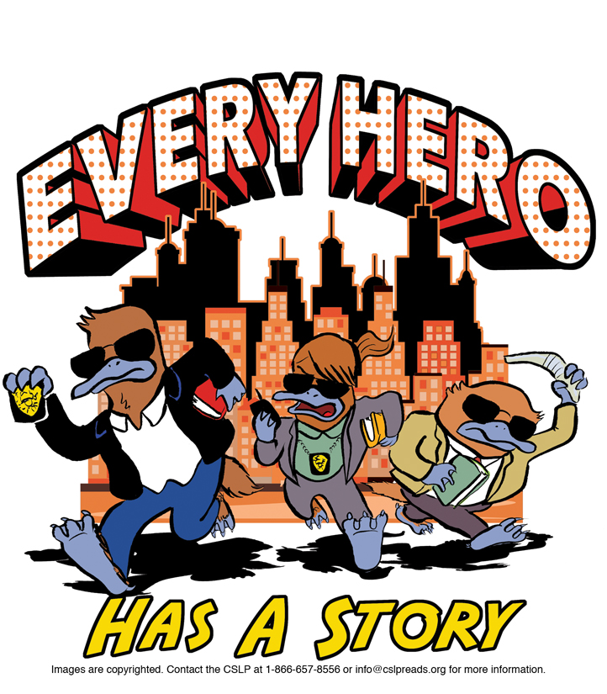

 | - Storytime: Preschool Pals (3 yrs – 5 yrs old)  Mondays at 1:30 PM  - Storytime: Terrific Tales for Toddlers (18 mo. – 3 yrs old)  Tuesdays at 10:30 AM and 11:30 AM  - Storytime: Baby & Me (birth – 18 mo.)  Thursdays at 10:30 AM and 11:30 AM  - Storytime: Family Fun (babies – 5 yrs old)  Mondays at 4:15 PM and Saturdays at 11:00 AM

New Bilingual Storytimes (for ages 3 to 5*)
This year we are trying out two new Storytimes that feature a non-English language volunteer
who will co-present the Storytime with us. Nurture the language development of children and
celebrate our city’s diverse cultures in this fun bilingual environment. Children and their parents or caregivers will sing songs, move with action rhymes, and share stories in English and another language. These 20-30 minute bilingual storytimes will expand emerging vocabularies and foster a love of reading. Children and adults will meet new friends as they explore, play, and learn in a positive and supportive environment. Our two programs are:

- Storytime: Chinese and English
2nd Mondays at 1:30 PM (July – December)
- Storytime: Spanish and English
3rd Saturdays at 11:00 AM (July – December)
*The programs are geared towards kids ages 3-5 and their parents and caregivers, but older and younger kids are welcome to attend as well.

Kids Create (for ages 5 – 10)
Wednesdays at 4 PM
Get crafty at the Library during our Kids Create programs! Children in grades K – 5 will be matched with their peer group so that they can explore artistic media with their hands, minds, and imaginations. Each peer group will develop fine motor coordination, listening skills, and the ability to follow single and multi-step directions while expressing their creativity.

Celebrate: Super Heroes event
Super heroes, local heroes, artistic heroes, sports heroes, visionary heroes, and every-day heroes – we’re celebrating all the ways that people can be heroic at our Celebrate Super Heroes event on
August 12th at 4:15 PM

2

I sometimes think that I don't let myself know what I'm really thinking about. That doesn't make much sense but it makes sense to me. I have this idea that the reason we have dreams is that we're thinking about things we don't know we're thinking about – and those
things, well, they sneak out of us in our dreams. Maybe we're like tires with too much air in them. The air has to leak out. That's what dreams are.
Benjamin Alire Saenz, (1954- ) Aristotle and Dante Discover the Secrets of the Universe
2

July 2015 Among Friends Volume IX, No. 3

Teen Summer Reading 2015  by Maddie Siegel, Teen Librarian  Unmask!  Summer Reading is already in full swing, but it’s not too late to join in on the fun! Teen Summer Reading (TSR) is a program intended to encourage teens to read during summer vacation. (We at the CLP identify you as a “teen” if you are entering grades 6-12 or are between the ages of 12 and 18.) |  |  | 
Studies show that teens who read in the summer gain important reading skills and have higher test scores when school starts again. All types of reading counts – books, magazines, newspapers, blogs and fanfiction. Reading to a child counts too! We just ask that teens list the other reading matter on their Summer Reading folder as they would a book.

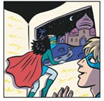 | How can teens participate?  Sign up Receive a free book. Select books from about 30 different titles we have available for prizes. These books include graphic novels, fiction, non-fiction, and manga. All titles were selected by a committee of teen librarians. So far teens have loved the prize books!  Read 2 books Receive a free book.  Read 3 more books Receive a free book & a raffle ticket for one of four $100 gift cards. Winners can choose from Barnes & Noble, iTunes, and Amazon. | 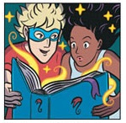

WAIT, THERE’S MORE !  While 5 books read completes the program, we encourage teens to keep reading. For every additional 5 books teens read they will receive another raffle ticket –  the more you read, the better your chances are of winning. |   your inner superhero! | ANOTHER AWESOME PERK !  Teen Fine Forgiveness:  When you sign up for Teen Summer Reading we will waive your Carnegie Library of Pittsburgh overdue fees!  The first year you sign up we waive all your fines; after that we will  waive up to $10.

We will be hosting teen programs every Tuesday and Thursday through August 27th from 3:30-5:00 PM.
 | Staff Notes | The Mighty Little Playaway
 | ■   | by Mark Russell, Librarian  Have you tried our Playaways? If you like listening to books anywhere and everywhere you go, the Playaway might be for
  you.  Playaways are a special variety of audiobook available at the Carnegie Library of Pittsburgh – Squirrel Hill and other locations. What makes Playaways special is the fact that you don’t need anything to play them: no CD player, tape deck, or MP3 device. The audiobook and | 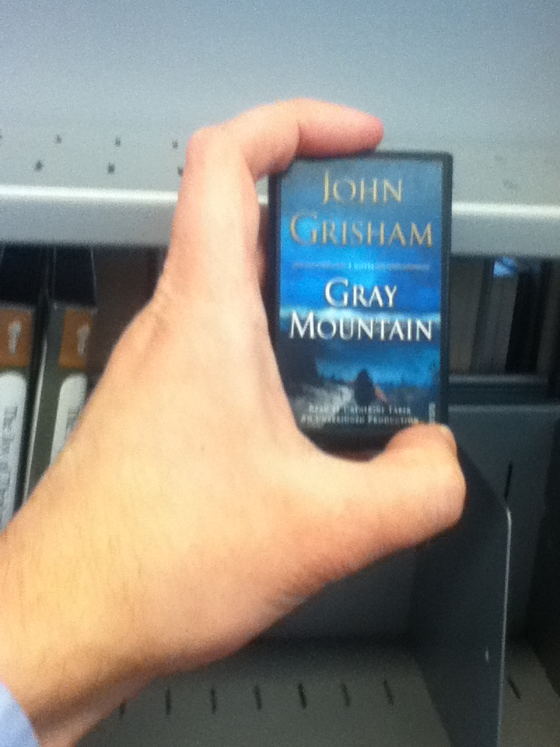 (Above: The mighty little Playaway; author’s hand  not included)
the player are combined in one incredibly convenient little package. Since we’ve been purchasing Playaways for a few years now, we have a selection that spans hundreds of titles that cover a variety of reading interests, like mysteries, memoirs, and romance. Our collection includes the latest titles from best-selling authors such as James Patterson, John Grisham, and Danielle Steel.

Playaways do require headphones and a AAA battery, which the library does not provide. They go out for three weeks and can be renewed twice, just like a book. We also have a portable video version that goes out for one week, called the Playaway View, which you can find in our Children’s Department.

If you need help finding our Playaways, or you would like a demonstration of how one works, just ask a librarian.
The judge said he was going to throw the book at me.
I hoped it was an eBook in the cloud, and not a heavy dictionary.
Jarod Kintz 99 Cents for Some Nonsense

3
4
July 2015 Among Friends Volume IX, No. 3

The Squirrel Hill  Adult Book Discussion Group  meets on Thursday  from 1:00 PM  to 2:00 PM  All are Welcome  July – no meeting  August 27  The Sixth Extinction:  An Unnatural History  by Elizabeth Kolbert  September 24  Five Came Back:  A Story of Hollywood  and the  Second World War  by Mark Harris | In My Humble Opinion  by Margie Spenser, newsletter tech staff  Carnegie Library of Pittsburgh has a new Adult Programming Coordinator, Dan Hensley, who is responsible for receiving and creating new program ideas and disseminating them to the various branches. He will be bringing new adult Programs to Squirrel Hill – CLP in the coming months. | 
FREE TECH STUFF: IHEARTRADIO for all smartphones. Get easy access to more than 750 Clear Channel stations across the U.S. Tune in to your favorite music or talk programs, tag songs for purchase later, even keep up with your local teams. Get free eBooks at BookBub.com. Amazon, Barnes & Noble, etc. offer books they hope will get you hooked on new authors. Use Kindle versions from Amazon on a non-Kindle device with a free app from Amazon.
Send paperbacks to other readers (you pay postage) and get ones you want free at paperbackswap.com.
 | Farewell to Aisha Hallman Since the October, 2012 issue of Among Friends, we’ve  had a marvelous array of adult programming spread before us by Aisha Hallman. Aisha came to CLP  from Fort Wayne, Indiana and has gone back west to Iowa. We’re going to miss her.

Looking over the issue of Among Friends for July 2014, I see that I was waiting to be notified that I could pick upThe Heart of June, the book I had on hold by our Local Author, Mason Radkoff. It was worth the wait. I’d also recommend Tomorrow and Tomorrow, by Thomas Sweterlitsch, who worked for 12 years in CLP’s Library for the Blind and Physically Handicapped. It takes place in a future where a terrorist’s suitcase bomb has wiped out Pittsburgh, but virtual reality software and old records from omnipresent surveillance cameras allow people to experience the city as though it’s still there. The hero keeps reliving scenes with his wife, who died in the city while he was on a business trip. Lots of other action occurs all over familiar Pittsburgh locales; the hero keeps taking the 54 bus. Be careful, though: there is an older science fiction book with the same title.
Unfortunately, due to the shortage of volunteers to mail books to purchasers, our online site is currently out of service. You can see everything, but all the books are marked “currently unavailable”.
Author Talk | Jennifer Pharr Davis will discuss  The Extra Mile: Exploring the Limits of Endurance  Wednesday, July 29th 6:00 PM
Jennifer Pharr Davis is a hiker, adventure speaker, and 2012 National Geographic Adventurer of the Year. She has written several books, including Becoming Odyssa: Epic Adventures on the Appalachian Trail and Called Again: A Story of Love and Triumph. She is also the owner and founder of Blue Ridge Hiking Company in Asheville, North Carolina. In 2011, Jennifer covered the 2,181 mile Appalachian Trail in 46 days, 11 hours, and 20 minutes and claimed the overall fastest time on the A.T.

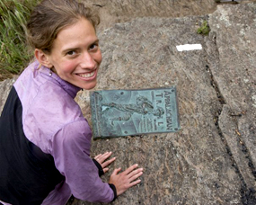 | Jennifer has appeared on national television shows such as CNN Headline News, Fox and Friends, The CBS Early Show, and The 700 Club, and her adventures have appeared in The Washington Post, The New York Times, and on NPR’s Talk of the Nation. She offers a riveting account of overcoming the odds and setting the 46-day, 47-mile-per-day Appalachian Trail record. She relays honestly the internal and external struggles of trying to maximize her miles and her potential.  This is an inspired tale of determination, endurance, and teamwork. If you want to be motivated to do more than you ever thought possible, this is the talk for you.

There is a temperate zone in the mind, between luxurious indolence and exacting work, and it is to this region, just between laziness and labor, that summer reading belongs. Henry Ward Beecher 1813-1887
HEART FELT THANKS
The Friends would like to express their tremendous gratitude to the Friend who has recently stepped down from his position as the coordinator of our online used books sales. Because of his dedication and generosity with his time, we were able to make significant profits of over $30,000 from sales of used books through Amazon. Since the money raised from our used book sales is put towards the expansion and enhancement of library collections and services, the entire community has benefited from his hard work. Thanks, Friend. (Our modest Friend has asked that his name not appear in the newsletter.)
and HELP WANTED
Our Friend’s departure has left us with a need for a Coordinator of Online Sales, as well as more volunteers who can assist with listing books online and shipping the books to their new owners. If you would like to help with this vital ongoing project, please go to our website and fill out the volunteer application: http://carnegielibrary.org/about/support/volunteer/. The Coordinator must have computer skills; he or she will train volunteers, order shipping supplies, schedule people for scanning and shipping duties, and assure that we are using Amazon properly and responsibly. Online selling experience is a plus, but not required!
4

July 2015 Among Friends Volume IX, No. 3

Organizing Mindfully
A Workshop with Joyce B. Wilde, M.S. September 2nd, 6:00 PM

Trying to get organized? Organizing will probably fail if it only addresses the symptoms of the disorganization and doesn’t get to the root causes. It’s like mowing the dandelions from your yard; they’ll just grow back. To make effective and lasting changes, you need to pull them out by the roots. In the same way, your physical surroundings are a reflection of your mental and emotional processes.
Come take a seminar with Joyce Wilde, author of the book The Wilde Woman’s Guide to Organizing in Five Simple Steps: Using Mindfulness to Change Your Habits, and learn how to pull those dandelions out by the roots. The workshop focuses on assisting women and men who would like to be organized as a way of living – rather than just getting temporarily organized. You’ll learn how to physically organize yourself and understand the emotional and mental roots that cause disorganization.  Joyce B. Wilde, M.S., is a psychologist, writer, professional organizer, and international speaker who helps creative professionals get through challenging transitions by teaching them how to organize effectively and communicate compassionately. | 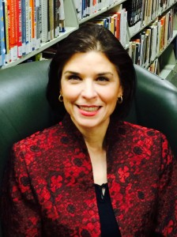
Ongoing Programs

The Writer’s Studio Sundays at 2:00 PM With Laurie Arnold, M.Ed
Join us each Sunday as we draw from creative exercises to free the muse and get to the stories we want to tell. Using various writing tools and discussion, we will embark on a journey to engage our creativity on the page. Fiction, nonfiction, poetry, and memoir samples will be used as springboards to spark the imagination for our own writing. Each week we will bring into play themes from our lives that crisscross literature, such as choice, risk, change, relationships, work, spirituality, and dreams. There will be time to share our writing and learn from each other. Beginners and experienced writers alike are welcome!

Yoga Tuesdays at 5:30 PM and Saturdays at 10:00 AM With Phyllis Berkovitz
Wear comfortable clothing, bring a floor covering, and enjoy the relaxation and healthy benefits of yoga.

Let’s Speak English Tuesdays at 6 PM
If English is not your native tongue, join our group for lively English conversation. (Let’s Speak English will be on hiatus during July.)
Writing a Legacy of Life 1st and 3rd Tuesdays at 1:00 PM With Ellen Dehouske, PhD
Begin a journey of personal exploration, learning, and adventure that will result in lasting memories for your family and others. We will help you organize your memories and get the stories of your life down on paper. No previous writing experience is necessary, but veteran writers are welcome.

Job and Career: Resume Assistance 1st and 3rd Tuesdays at 6:00 PM
Free one-on-one assistance is available to help you develop a strong resume so you can land an interview. Bring a copy of your resume. Space is limited. To Register email squirrelhillprograms@carnegielibrary.org, ask a librarian, or call 412-422-9650.

The Origami Club 3rd Saturday of July, September, and November Beginners Models noon to 1:15; Informal Folding 1:30 to 3
The Origami Club of Pittsburgh (OCoP) has been meeting at the Sq. Hill Branch since 1988 (27 years!) . Young children (ages 7-8) should be accompanied by an adult. For more information, go to www.origamiclubofpgh.org/ or call 412-741-3173.

Give Your Air a Check with Speck  Speck is an air quality monitor that has been developed by Arviz, a spinoff of the CREATE labs at Carnegie Mellon University Robotics Institute. Speck detects the presence and quantity of fine particulate matter in the air, and it can transmit this information wirelessly to a computer or wireless device. Fine particles have been identified as a pollutant by the Environmental Protection Agency and the American Lung Association, and they can contribute to or worsen illnesses such as asthma, emphysema, and chronic bronchitis.  The Heinz Endowments and Pittsburgh Foundation have purchased many Specks and they are making them | *  by Allison Marciszyn  If you are like many library patrons, you not only want to take stories in; you might have stories you are trying to get out. There are several writing groups associated with CLP, but if they don’t fit your schedule, or you just aren’t ready to share your words, there is online support available.  National Novel Writing Month (NaNoWriMo) is a non-profit group that offers online support, organization, and encouragement to help participants finally get that great American novel out of their heads and onto their computers. Budding writers can log on to find writing development exercises, discussion forums, and writing groups (both online and in person).  The website (www.nanowrimo.org) has several programs each year, including the original November challenge (50,000 words in one month), the more flexible Camp NaNoWriMo (writer-selected goal for July), and programs tailored to younger writers and their teachers. Whether writing is your hobby or your intended profession, NaNoWriMo is a great place to start.  *image courtesy of National Novel Writing Month  * * * * * * * * *  More than 250 NaNoWriMo novels have been published traditionally, including Water  for Elephants by Sara Gruen and Cinder, the first of Melissa Meyer’s trilogy of Lunar Chronicles. Superb books; I read them this year and I’ll read them again. -- Margie Spenser  5
  available through various community organizations. The Carnegie Library of Pittsburgh – Squirrel Hill is leading the way in this initiative, and Specks can be checked out on your library card from CLP Squirrel Hill for three weeks. Try one out today! | 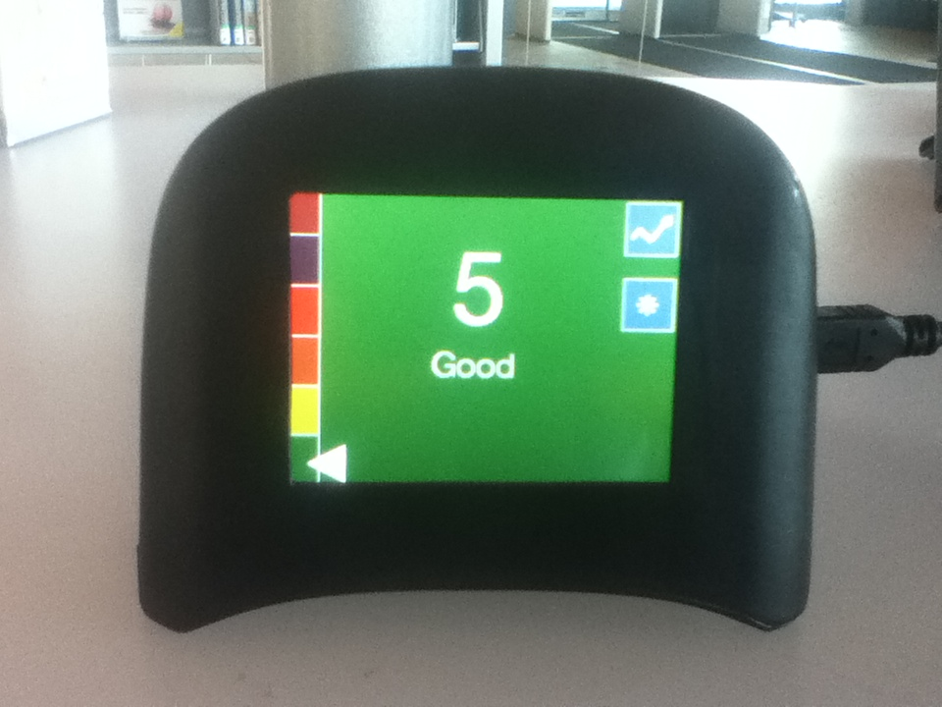

CARNEGIE LIBRARY OF  5  PITTSBURGH –  SQUIRREL HILL  5801 Forbes Avenue  Pittsburgh, PA 15217  Adult Services: 412-422-9650  Children's Services: 412-422-9841  Fax: 412-422-5811  www.carnegielibrary.org/clp/sq | ADDRESS SERVICE REQUESTED  Your donation is tax deductible as a charitable contribution. | 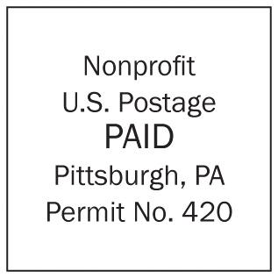
  
  «exptext»  «expdate» | «first» «last»  «addr»  Pittsburgh, PA «zip» «zip2»
Is your Friends Membership up to date? Please check your mailing label. ➔
If the date is before 07/15, you need to renew. Mail us the form below.
ALL CLP BRANCHES WILL BE CLOSED ON
INDEPENDENCE DAY, SATURDAY, JULY 4TH
AND LABOR DAY, MONDAY, SEPTEMBER 7TH

Our language classes will be starting back up in September after a summer vacation.
Contact the library for days and times.

July 2015 Among Friends Volume IX, No. 3

Make checks payable to:  Friends of the Squirrel Hill Library  and mail to:  Allison Marciszyn  2309 Woodstock Ave.  Swissvale, PA 15218  SqHiFriendsLib@gmail.com  Check one box:  New Member Renewal  Check one or two boxes:  $5.00 $10.00 $15.00  $25.00 $50.00 Other ____  CLP DONOR CARD MEMBER (the first year is free, but we gladly accept donations.)  Name:___________________________________  ^{(Last)} ^{(First)}  Address: _________________________________  City/State: __________________Zip: __________  Phone(s): ___________________Date: _________  E-mail address: ____________________________  Please check all activities you can help with:  Stocking Book Sale Shelves Library Advocacy  Sorting Used Books Gardening  Keeping Sale Shelves Neat Publicity  COMMENTS: | Genre Book Club  meets the third Wednesday  of the month at 6:30 pm.  July 15  I Capture the Castle by Dodie Smith  (a classic story of love and family)  August 19  Into the Wild by Jon Krakauer  (a real-life mystery)  September 16  The Martian by Andy Weir  (science fiction)  I guess you can call me “old fashioned”. I prefer the book with the pages that you can actually turn.... Nothing beats the sound that an actual, physical book makes when you first crack it open or the smell of new, fresh printed words on the creamy white paper of a page turner.  Felicia Johnson | Art at the  Squirrel Hill Library    Coming up are:  July: Ed Yarov  oils  August: Bonnie Gloria  mixed  September: Jacque Kehm  oils  We are scheduled through  February, 2016.  To exhibit after that,  call Marion Damick  at 412-521-3075.  Friends Officers  Marion Damick President  Joan Schwartzman Vice President  Eleanor Hershberg Treasurer  Rita Motor Secretary  Email .friends@pittsburghusedbooks.com
6

